**Instructions:**

* For problems 1 and 2 please submit your code in an R script. Save your plots as png files and upload them. For problem 3, you only need to submit the Shiny app script.
* Name your files in the following format to identify each problem: “Last name + First Name + Problem #”.

# Problem 1 (30%)

Use the file bank_stocks_2022_2023.csv for this problem. This file contains the daily stock prices (at market close) of the four largest U.S. banks during the last year: JP Morgan Chase (JPM), Bank of America (BAC), Citigroup (Citi), and Wells Fargo (WFC).

1. (15%) Make a line graph that compares the stock performance of the four banks (make sure the date variable is converted to the date format). Your output should look like the following.

Stock performance of the four largest US banks, 2022−2023

100

Price

50

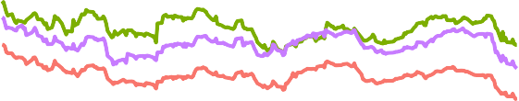

Apr 2022 Jul 2022 Oct 2022 Jan 2023 Apr 2023

Date

Banks

BAC

Citi JPM WFC

1. (15%) Based on your plot in part a, add a line that represents the *average* stock price of the four banks. Your plot should look like the following.

Stock performance of the four largest US banks, 2022−2023

100

Price

50

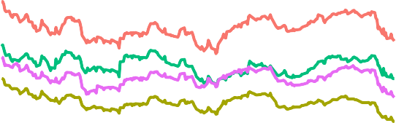

Apr 2022 Jul 2022 Oct 2022 Jan 2023 Apr 2023

Date

Banks

Average BAC

Citi JPM WFC

# Problem 2 (30%)

Use the file state_health_insurance_coverage_2021 for this problem. Make a map of uninsured rate by state (the Uninsured variable in the dataset). For simplicity, you may exclude Alaska and Hawaii from the output. Make sure that you map includes proper legends and labels. Your map should look like the following (for fill colors use skyblue for lower values and blue4 for higher values).

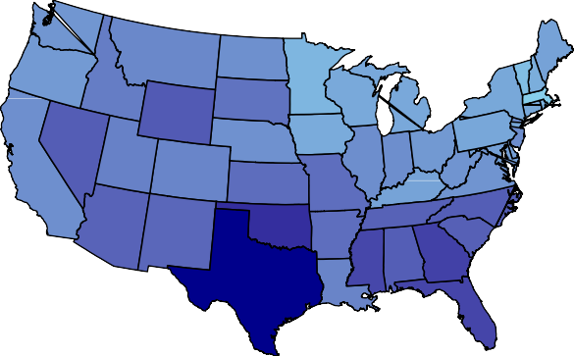Percentage of residents without health insurance coverage in the U.S., 2021

Uninsured rate



0.20

0.15

0.10

0.05

# Problem 3 (40%)

Use the file cpi.csv for this problem. The variable cpi is the consumer price index (CPI). Percent changes in the index are used to measure the inflation rate between any two periods. Create a dashboard that has the functionalities described below. You can choose to create a two-page app or two separate apps. Note that if you choose to build a two-page app, the input IDs need to be unique on both pages.

1. (15%) The user can select two periods (i.e., based on year and month) and the app will produce a ***line graph*** that shows the evolution of the CPI between these two periods. This part should look like the following.

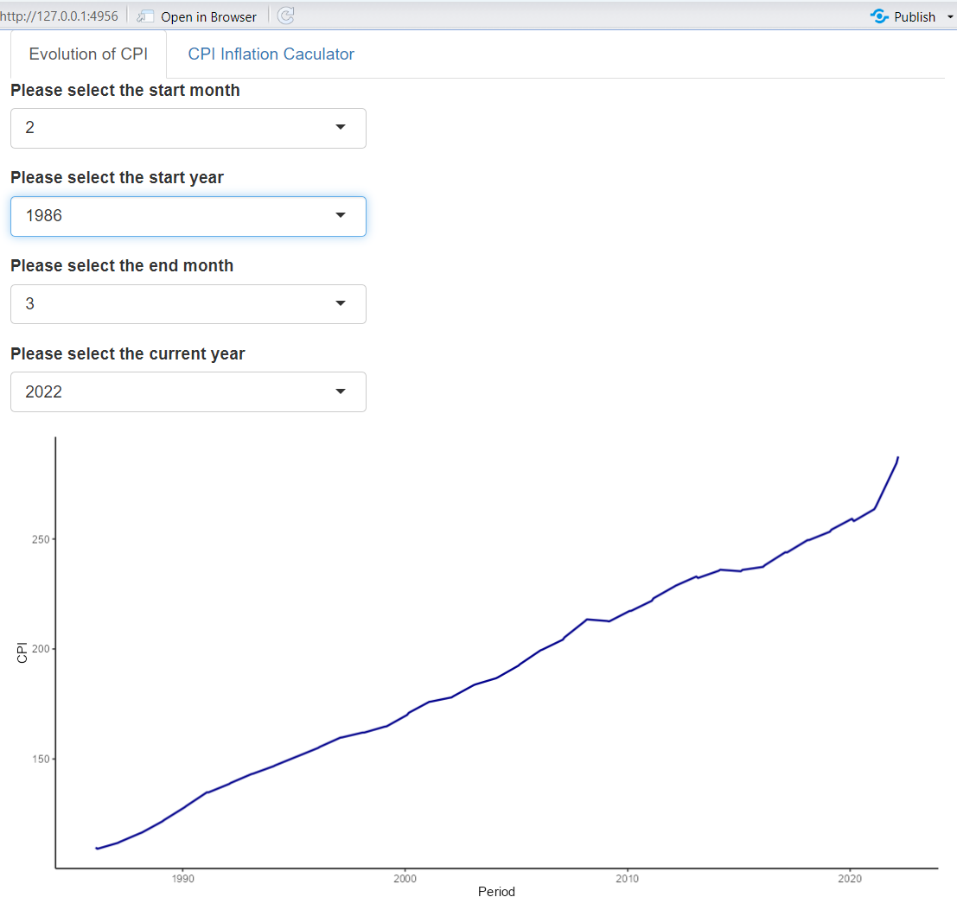

1. (15%) The user can select two periods (a base period and a current period). The app can convert the dollar values entered by the user between the two periods. The formula for the conversion is (*CPIcurrent/CP Ibase*) dollar amount. For example, the CPI in January 2020 is 258.906, and the CPI in January 2023 is 300.356. Therefore, $100 in January 2020 has the same buying power as 300*.*356 *×* 100 = $116 in January 2023. This

*×*

258*.*906

part should look like the following.

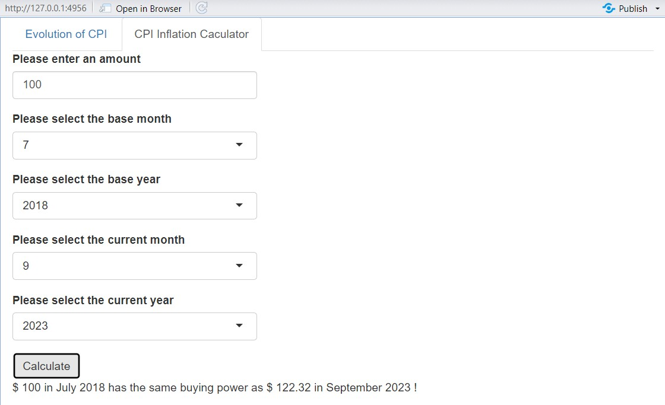

1. (10%) Add an action button to the app in part b so that the results only change after the user clicks the button.
2. (Extra credit; 10%) Modify the app(s) such that the user can select from a list of full month names instead of numeric values. This part should look like the following.

